Operations Management, 10e, Global Edition (Heizer/Render)
Chapter 13 Aggregate Planning

1) Aggregate planning occurs over the medium or intermediate future of 3 to 18 months.
Answer: TRUE
Diff: 1
Topic: The planning process
Objective: LO13-1

2) The only objective of aggregate planning is to minimize the cost of matching capacity to demand over the planning period.
Answer: FALSE
Diff: 1
Topic: The planning process
Objective: LO13-1

3) Aggregate planning in manufacturing ties organizational strategic goals to a production plan.
Answer: TRUE
Diff: 2
Topic: The planning process
Objective: LO13-1

4) One of the four things needed for aggregate planning is a logical overall unit for measuring sales and output.
Answer: TRUE
Diff: 2
Topic: The planning process
Objective: LO13-1

5) Plans for new product development generally fall within the scope of aggregate planning.
Answer: FALSE
Diff: 2
Topic: The planning process
Objective: LO13-1

6) The aggregate planning process usually includes expediting and dispatching of individual products.
Answer: FALSE
Diff: 2
Topic: The planning process
Objective: LO13-1

7) Disaggregation is the process of breaking the aggregate plan into greater detail; one example of this detail is the Master Production Schedule.
Answer: TRUE
Diff: 2
Topic: The nature of aggregate planning
Objective: LO13-1
8) One question that operations managers must ask when generating an aggregate plan is what factors are likely to influence demand and by how much.
Answer: TRUE
Diff: 1
Topic: Aggregate planning strategies
Objective: LO13-2

9) One of the demand options of aggregate planning is to vary the workforce by hiring or layoffs.
Answer: FALSE
Diff: 2
Topic: Aggregate planning strategies
Objective: LO13-2

10) The strategies of aggregate planning are broadly divided into demand options and capacity options.
Answer: TRUE
Diff: 1
Topic: Aggregate planning strategies
Objective: LO13-2

11) In aggregate planning, the amount of overtime and the size of the work force are both adjustable elements of capacity.
Answer: TRUE
Diff: 1
Topic: Aggregate planning strategies
Objective: LO13-2

12) In aggregate planning, one of the adjustable elements of capacity is the extent of subcontracting.
Answer: TRUE
Diff: 1
Topic: Aggregate planning strategies
Objective: LO13-2

13) One motive for using demand-influencing aggregate planning options is to create uses for excess capacity within an organization.
Answer: TRUE
Diff: 2
Topic: Aggregate planning strategies
Objective: LO13-2

14) The use of part-time workers as an aggregate planning option may be less costly than using full-time workers, but may also reduce quality levels.
Answer: TRUE
Diff: 2
Topic: Aggregate planning strategies
Objective: LO13-2
15) Advertising and promotion are methods of manipulating product or service supply in aggregate planning.
Answer: FALSE
Diff: 2
Topic: Aggregate planning strategies
Objective: LO13-2

16) Because service firms do not inventory their output, pure chase strategy is not appropriate.
Answer: FALSE
Diff: 2
Topic: Aggregate planning strategies
Objective: LO13-2

17) The level scheduling strategy allows lower inventories than the pure chase strategy.
Answer: FALSE
Diff: 2
Topic: Aggregate planning strategies
Objective: LO13-2

18) Mixed strategies in aggregate planning utilize inventory, work force, and production rate changes over the planning horizon.
Answer: TRUE
Diff: 2
Topic: Aggregate planning strategies
Objective: LO13-2

19) Finding an ideal mixed strategy is complicated by the huge number of possible strategies.
Answer: TRUE
Diff: 2
Topic: Aggregate planning strategies
Objective: LO13-2

20) Graphical techniques are easy to understand and use, but are not well-suited for generating optimal strategies.
Answer: TRUE
Diff: 2
Topic: Methods for aggregate planning
Objective: LO13-3

21) The transportation method of linear programming is an optimizing approach to aggregate planning.
Answer: TRUE
Diff: 1
Topic: Methods for aggregate planning
Objective: LO13-4
22) The management coefficients model is a formal planning model built around a manager's experience and performance.
Answer: TRUE
Diff: 2
Topic: Methods for aggregate planning
Objective: no LO
23) Controlling the cost of labor in services involves quick response to consumer demand, on-call labor for unexpected demand, flexibility of labor for reallocation, and flexibility of hours or rate of output of individual workers.
Answer: TRUE
Diff: 2
Topic: Aggregate planning in services
Objective: no LO

24) Aggregate planning for fast food restaurants is very similar to aggregate planning in manufacturing, but with much smaller units of time.
Answer: TRUE
Diff: 2
Topic: Aggregate planning in services
Objective: no LO

25) A hotel room that goes unrented and an airline seat that goes unsold are both examples of perishability of services inventory.
Answer: TRUE
Diff: 2
Topic: Aggregate planning in services
Objective: no LO

26) Frito-Lay uses aggregate planning to match capacity with demand because of the __________ associated with its specialized processes.
A) high variable cost, high fixed cost
B) high variable cost, low fixed cost
C) low variable cost, high fixed cost
D) low variable cost, low fixed cost
E) none of the above
Answer: C
Diff: 2
Topic: Global company profile
Objective: no LO
27) The typical time horizon for aggregate planning is
A) less than a month
B) up to 3 months
C) 3 to 18 months
D) over one year
E) over 5 years
Answer: C
Diff: 1
Topic: The planning process
Objective: LO13-1

28) Which of the following is the term used for medium range capacity planning with a time horizon of three to eighteen months?
A) material requirements planning
B) short-range planning
C) strategic planning
D) aggregate planning
E) none of the above
Answer: D
Diff: 1
Topic: The planning process
Objective: LO13-1

29) Aggregate planning is capacity planning for
A) the long range
B) the intermediate range
C) the short range
D) typically one to three months
E) typically three or more years
Answer: B
Diff: 1
Topic: The planning process
Objective: LO13-1

30) The objective of aggregate planning is to meet demand while __________ over the planning period.
A) minimizing cost
B) maximizing service level
C) minimizing stock out
D) minimizing fixed cost
E) all of the above
Answer: A
Diff: 2
Topic: The planning process
Objective: LO13-1
31) Which of the following is not one of the four things needed for aggregate planning?
A) a logical overall unit for measuring sales and output
B) a method for determining costs, such as hiring, layoffs, and inventory costs, associated with production schedules
C) a mathematical model that will minimize costs over the intermediate planning period
D) an aggregate demand forecast for an intermediate planning period
E) All of these are needed for aggregate planning.
Answer: C
Diff: 1
Topic: The planning process
Objective: LO13-1

32) Planning tasks associated with loading, sequencing, expediting, and dispatching typically fall under
A) short-range plans
B) intermediate-range plans
C) long-range plans
D) mission-related planning
E) strategic planning
Answer: A
Diff: 2
Topic: The planning process
Objective: LO13-1

33) The planning tasks associated with staffing, production, inventory, and sub-contracting levels typically fall under
A) short-range plans
B) intermediate-range plans
C) long-range plans
D) demand options
E) strategic planning
Answer: B
Diff: 1
Topic: The planning process
Objective: LO13-1

34) Which of the following statements about aggregate planning is true?
A) Advertising/promotion is a way of manipulating product or service supply.
B) Work station loading and job assignments are examples of aggregate planning.
C) Overtime/idle time is a way of manipulating product or service demand.
D) Aggregate planning uses the adjustable part of capacity to meet production requirements.
E) All of the above are true.
Answer: D
Diff: 2
Topic: The planning process
Objective: LO13-1
35) Which of the following statements about aggregate planning is false?
A) Hiring, layoffs, overtime, and subcontracting are methods of manipulating capacity.
B) Aggregate planning produces a plan detailing which products are made and in what quantities.
C) Yield management is a way of manipulating product or service demand.
D) Aggregate planning uses the adjustable part of capacity to meet production requirements.
E) The transportation method is an optimizing technique for aggregate planning.
Answer: B
Diff: 2
Topic: The planning process
Objective: LO13-1

36) As the level of management working on a forecast increases the __________ associated with the forecast also __________.
A) duration, increases
B) duration, decreases
C) cost, decreases
D) accuracy, increases
E) both A and D
Answer: A
Diff: 2
Topic: The planning process
Objective: LO13-1

37) Which of the following would most likely fall under the scope of only an operations manager?
A) research and development
B) new product plans
C) capital investments
D) facility location and expansion
E) setting inventory levels
Answer: E
Diff: 2
Topic: The planning process
Objective: LO13-1

38) Disaggregation
A) breaks the aggregate plan into greater detail
B) transforms the master production schedule into an aggregate plan
C) calculates the optimal price points for yield management
D) converts product schedules and labor assignments to a facility-wide plan
E) is an assumption required for the use of the transportation model in aggregate planning
Answer: A
Diff: 1
Topic: The nature of aggregate planning
Objective: LO13-1
39) Aggregate planning would entail which of the following production aspects at BMW for a 12 month period?
A) number of 3 Series cars to produce
B) number of 3 Series that will be coupes instead of sedans
C) number of 3 Series that will be green
D) total number of cars to produce
E) A, B, and D
Answer: E
Diff: 2
Topic: The nature of aggregate planning
Objective: LO13-1

40) Which of the following business components mostly likely influence aggregate planning?
A) research and Technology
B) inventory on hand
C) workforce size
D) demand forecasts
E) all of the above
Answer: E
Diff: 2
Topic: The nature of aggregate planning
Objective: LO13-1

41) To what level of detail does a master production schedule go?
A) total number of cars to be produced by a manufacturer
B) total number of push mowers that Snapper should produce
C) total number of each individual product should be produced
D) quantity and timing for production of every final product
E) quantity and timing for purchase of components used to make final products
Answer: E
Diff: 2
Topic: The nature of aggregate planning
Objective: LO13-1

42) Dependence on an external source of supply is found in which of the following aggregate planning strategies?
A) varying production rates through overtime or idle time
B) subcontracting
C) using part-time workers
D) back ordering during high demand periods
E) hiring and laying off
Answer: B
Diff: 2
Topic: Aggregate planning strategies
Objective: LO13-2
43) Which of these is among the demand options of aggregate planning?
A) subcontracting
B) back-ordering during high-demand periods
C) changing inventory levels
D) varying workforce size
E) All of the above are demand options.
Answer: B
Diff: 2
Topic: Aggregate planning strategies
Objective: LO13-2

44) Which of the following aggregate planning strategies might direct your client to a competitor?
A) using part-time workers
B) subcontracting
C) changing inventory level
D) varying production rates through overtime or idle time
E) varying work force size by hiring or layoffs
Answer: B
Diff: 2
Topic: Aggregate planning strategies
Objective: LO13-2

45) Which of the following aggregate planning strategies is a "capacity option"?
A) influencing demand by changing price
B) counterseasonal product mixing
C) influencing demand by extending lead times
D) changing inventory levels
E) influencing demand by back ordering
Answer: D
Diff: 2
Topic: Aggregate planning strategies
Objective: LO13-2

46) Which of these aggregate planning strategies adjusts capacity to match demand?
A) back ordering
B) using part-time workers
C) counterseasonal product mixing
D) changing price
E) None of the above is a capacity option.
Answer: B
Diff: 2
Topic: Aggregate planning strategies
Objective: LO13-2
47) Which of the following aggregate planning strategies is known to lower employee morale?
A) yield management
B) counterseasonal product and service mixing
C) changing inventory levels
D) varying work force size by hiring or layoffs
E) back ordering during high demand periods
Answer: D
Diff: 2
Topic: Aggregate planning strategies
Objective: LO13-2

48) Which of the following is not associated with manipulation of product or service demand?
A) price cuts or discounts
B) promotion
C) subcontracting
D) counterseasonal products or services
E) advertising
Answer: C
Diff: 2
Topic: Aggregate planning strategies
Objective: LO13-2

49) Which of the following attempts to manipulate product or service demand?
A) inventories
B) part-time workers
C) subcontracting
D) overtime/idle time
E) price cuts
Answer: E
Diff: 2
Topic: Aggregate planning strategies
Objective: LO13-2

50) Which of the following aggregate planning strategies is a "demand option"?
A) changing price
B) subcontracting
C) varying production levels
D) changing inventory levels
E) using part-time workers
Answer: A
Diff: 2
Topic: Aggregate planning strategies
Objective: LO13-2
51) In aggregate planning, which one of the following is not a basic option for altering demand?
A) promotion
B) subcontracting
C) back ordering
D) pricing
E) All are demand options.
Answer: B
Diff: 2
Topic: Aggregate planning strategies
Objective: LO13-2

52) Which choice below best describes the counterseasonal demand option?
A) producing such products as lawnmowers and sunglasses during the winter
B) developing a mix of products that smoothes out their demands
C) lowering prices when demand is slack
D) using subcontractors only when demand is excessive
E) the breaking of the aggregate plan into finer levels of detail
Answer: B
Diff: 1
Topic: Aggregate planning strategies
Objective: LO13-2

53) Which of the following statements about aggregate planning is true?
A) The development of mathematical models has allowed aggregate planners to discontinue use of trial-and-error methods.
B) In aggregate planning, back orders are a means of manipulating supply while part-time workers are a way of manipulating product or service demand.
C) A pure chase strategy allows lower inventories when compared to pure level scheduling.
D) Disaggregation turns the master production schedule into an intermediate term master plan.
E) All of the above are true.
Answer: C
Diff: 2
Topic: Aggregate planning strategies
Objective: LO13-2

54) Which choice best describes level scheduling?
A) Daily production is variable from period to period.
B) Subcontracting, hiring, and layoffs manipulate supply.
C) Price points are calculated to match demand to capacity.
D) Inventory goes up or down to buffer the difference between demand and production.
E) Seasonal demand fluctuations are matched without hirings or layoffs.
Answer: D
Diff: 1
Topic: Aggregate planning strategies
Objective: LO13-2
55) Which of the following statements regarding aggregate planning is true?
A) In a pure level strategy, production rates or work force levels are adjusted to match demand requirements over the planning horizon.
B) A pure level strategy allows lower inventories when compared to pure chase and hybrid strategies.
C) In a mixed strategy, there are changes in both inventory and in work force and production rate over the planning horizon.
D) Because service firms have no inventory, the pure chase strategy does not apply.
E) All of the above are true.
Answer: C
Diff: 2
Topic: Aggregate planning strategies
Objective: LO13-2

56) In level scheduling, what is kept uniform from month to month?
A) product mix
B) inventory levels
C) production/workforce levels
D) demand levels
E) sub-contracting levels
Answer: C
Diff: 2
Topic: Aggregate planning strategies
Objective: LO13-2

57) Which of the following is not consistent with a pure level strategy?
A) varying the use of subcontracting
B) variable work force levels
C) little or no use of inventory to meet demand requirements
D) varying production levels and/or work force to meet demand requirements
E) All of the above are inconsistent with the pure level strategy.
Answer: E
Diff: 2
Topic: Aggregate planning strategies
Objective: LO13-2

58) Which of the following is consistent with a pure chase strategy?
A) vary production levels to meet demand requirements
B) vary work force to meet demand requirements
C) vary production levels and work force to meet demand requirements
D) little or no use of inventory to meet demand requirements
E) All of the above are consistent with a pure chase strategy.
Answer: E
Diff: 2
Topic: Aggregate planning strategies
Objective: LO13-2
59) Which of the following is not an advantage of level scheduling?
A) stable employment
B) lower absenteeism
C) matching production exactly with sales
D) lower turnover
E) more employee commitment
Answer: C
Diff: 2
Topic: Aggregate planning strategies
Objective: LO13-2

60) A firm uses the pure chase strategy of aggregate planning. It produced 1000 units in the last period. Demand in the next period is estimated at 800, and demand over the next six periods (its aggregate planning horizon) is estimated to average 900 units. In following the chase strategy, the firm will
A) add 100 units to inventory in the next period
B) add 200 units to inventory in the next period
C) hire workers to match the 100 unit difference
D) lay off workers to match the 200 unit difference
E) implement a lower price point to increase demand
Answer: D
Diff: 2
Topic: Aggregate planning strategies
AACSB: Analytic Skills
Objective: LO13-2

61) A firm's demand in the next four quarters (its aggregate planning horizon) is forecast to be 80, 50, 40, and 90 units. Last quarter, the firm produced 60 units. If it uses level scheduling, the firm will.
A) hire workers to permit production of 65 units per quarter for the next four quarters
B) hire 20 workers
C) have an increase in inventory of 20 units in the next quarter
D) have a decrease in inventory of 5 units in the next quarter
E) change its workforce each quarter so that inventory does not change
Answer: A
Diff: 2
Topic: Aggregate planning strategies
AACSB: Analytic Skills
Objective: LO13-2

62) Which of the following actions is consistent with the use of pure level strategy?
A) use inventory to meet demand requirements
B) vary the amount of subcontracting to meet demand requirements
C) vary production levels to meet demand requirements
D) vary work force to meet demand requirements
E) none of the above
Answer: A
Diff: 2
Topic: Aggregate planning strategies
Objective: LO13-2
63) A firm practices the pure chase strategy. Production last quarter was 1000. Demand over the next four quarters is estimated to be 900, 700, 1000, and 1000. Hiring cost is $20 per unit, and firing cost is $5 per unit. Over the next year, the sum of hiring and layoff costs will be
A) $500
B) $2,500
C) $7,500
D) $7,000
E) $12,500
Answer: C
Diff: 2
Topic: Aggregate planning strategies
AACSB: Analytic Skills
Objective: LO13-2

64) "An optimal plan for minimizing the cost of allocating capacity to meet demand over several planning periods" best describes
A) the linear decision rule
B) simulation
C) the management coefficients model
D) the transportation method
E) graphical methods
Answer: D
Diff: 2
Topic: Methods for aggregate planning
Objective: LO13-4

65) A firm uses graphical techniques in its aggregate planning efforts. Over the next twelve months (its intermediate period) it estimates the sum of demands to be 105,000 units. The firm has 250 production days per year. In January, which has 22 production days, demand is estimated to be 11,000 units. A graph of demand versus level production will show that
A) the January requirement is below level production of 420 units
B) level production is approximately 1000 units per day
C) level production of 420 units per day is below the January requirement
D) level production is approximately 420 units per month
E) the firm must hire workers between December and January
Answer: C
Diff: 1
Topic: Methods for aggregate planning
AACSB: Analytic Skills
Objective: LO13-3
66) Which of the following aggregate planning models is based primarily upon a manager's past experience?
A) the linear decision rule
B) simulation
C) the management coefficients model
D) the transportation method
E) graphical methods
Answer: C
Diff: 2
Topic: Methods for aggregate planning
Objective: no LO

67) Which of the following aggregate planning methods does not work if hiring and layoffs are possible?
A) the linear decision rule
B) simulation
C) the management coefficients model
D) the transportation method
E) graphical methods
Answer: D
Diff: 2
Topic: Methods for aggregate planning
Objective: LO13-4

68) Which of the following uses regression to incorporate historical managerial performance into aggregate planning?
A) transportation method
B) simulation
C) linear decision rule
D) management coefficients model
E) keiretsu
Answer: D
Diff: 2
Topic: Methods for aggregate planning
Objective: no LO
69) A manager is applying the transportation model of linear programming to solve an aggregate planning problem. Demand in period 1 is 100 units and in period 2 demand is 150 units. The manager has 125 hours of regular employment available for $10/hour each period. In addition, 50 hours of overtime are available for $15/hour each period. If holding costs are $2 per unit each period, how many hours of regular employment should be used in period 1 (assume demand must be met in both periods 1 and 2 for the lowest possible cost and that production is 1 unit per hour)?
A) 100
B) 125
C) 150
D) 50
E) none of the above
Answer: B
Diff: 2
Topic: Methods for aggregate planning
AACSB: Analytic Skills
Objective: LO13-4

70) One reason complex models have not found widespread use and application is that
A) managers are lazy
B) managers cannot understand how they work
C) the models are inaccurate
D) good models are time-consuming and managers must often react swiftly to dynamic demand
E) the statement is false; complex models are widely used and accepted
Answer: D
Diff: 2
Topic: Methods for aggregate planning
Objective: no LO

71) Which of the following is not an ingredient for controlling labor cost in services?
A) accurate scheduling of labor-hours to assure quick response to customer demand
B) an on-call labor resource that can be added or deleted to meet unexpected demand
C) contract overseas labor to obtain a lower wage scale
D) flexibility of individual worker skills that permits reallocation of available labor
E) flexibility in rate of output or hours of work to meet changing demand
Answer: C
Diff: 2
Topic: Aggregate planning in services
Objective: no LO
72) Which of the following statements regarding aggregate planning in services is false?
A) When outputs are intangible, aggregate planning deals mainly with human resource requirements and managing demand.
B) Perishability of inventory is an important consideration of planning.
C) Aggregate planning in some service industries can be simpler than in manufacturing.
D) Labor is the primary aggregate planning vehicle.
E) Level scheduling is far more common than chase.
Answer: E
Diff: 1
Topic: Aggregate planning in services
Objective: no LO

73) Aggregate planning for service firms that provide intangible output deals mainly with
A) smoothing the production rate and finding the optimal size of the workforce
B) yield management
C) centralized purchasing
D) centralized production
E) planning for human resource requirements and managing demand
Answer: E
Diff: 2
Topic: Aggregate planning in services
Objective: no LO

74) Which of these is not a characteristic that makes yield management attractive?
A) demand can be segmented
B) service can be sold in advance of consumption
C) capacity is easily changed
D) variable costs are low and fixed costs are high
E) demand fluctuates
Answer: C
Diff: 1
Topic: Aggregate planning in services
Objective: no LO

75) Yield management is most likely to be used in which one of the following situations?
A) a fast food restaurant with wide demand fluctuations during the day
B) a dental clinic that wants to fill its appointment book
C) a firm with a good counterseasonal product mix
D) a shipping company that can change its fleet size easily
E) an airline attempting to fill "perishable" seats at maximum revenue
Answer: E
Diff: 3
Topic: Yield management
Objective: LO13-5
76) "Yield management" is best described as
A) a situation where management yields to labor demands
B) a situation where the labor union yields to management demands
C) a process designed to increase the rate of output
D) capacity allocation to different classes of customers in order to maximize profits
E) management's selection of a product mix yielding maximum profits
Answer: D
Diff: 2
Topic: Yield management
Objective: LO13-5

77) A coffee shop charges $4 for a regular size white chocolate coffee but only $2.50 for a regular coffee, despite the fact that variable cost between the two is almost negligible (under $.1 to add the white chocolate). In effect the shop has price discriminated between two classes of customers, frugal and luxury. This practice is known as
A) yield management
B) highly illegal
C) capacity management
D) aggregate planning
E) none of the above
Answer: A
Diff: 2
Topic: Yield management
Objective: LO13-5

78) To use yield management strategies a business should have which combination of costs?
A) high variable and high fixed
B) low variable and high fixed
C) high variable and low fixed
D) low variable and low fixed
E) either A or B
Answer: B
Diff: 2
Topic: Yield management
Objective: LO13-5

79) __________ is an approach to determine the quantity and timing of production for the intermediate future.
Answer: Aggregate planning
Diff: 1
Topic: The planning process
Objective: LO13-1

80) __________ is the process of breaking the aggregate plan into greater detail.
Answer: Disaggregation
Diff: 2
Topic: The nature of aggregate planning
Objective: LO13-1
81) A(n) __________ is the result of the disaggregation of the aggregate plan.
Answer: master production schedule
Diff: 2
Topic: The nature of aggregate planning
Objective: LO13-1

82) __________ is a capacity option that works especially well in the service sector where labor needs are relatively unskilled.
Answer: Using part-time workers
Diff: 2
Topic: Aggregate planning strategies
Objective: LO13-2

83) Developing a mix of __________ products is a widely used demand smoothing technique.
Answer: counterseasonal
Diff: 2
Topic: Aggregate planning strategies
Objective: LO13-2

84) The __________ strategy sets production equal to forecasted demand.
Answer: chase
Diff: 1
Topic: Aggregate planning strategies
Objective: LO13-2

85) The __________ strategy maintains a constant output rate, or work force level, over the planning horizon.
Answer: level
Diff: 1
Topic: Aggregate planning strategies
Objective: LO13-2

86) __________ work with a few variables at a time and are easy to understand and use.
Answer: Graphical methods
Diff: 2
Topic: Methods for aggregate planning
Objective: LO13-3

87) Among the mathematical approaches to aggregate planning, __________ is good at working with inventories, holding costs, overtime, and subcontracting, but not with hiring and layoffs.
Answer: the transportation method or linear programming
Diff: 2
Topic: Methods for aggregate planning
Objective: LO13-4
88) The __________ is a formal planning model built around a manager's experience and performance.
Answer: management coefficients model
Diff: 2
Topic: Methods for aggregate planning
Objective: no LO

89) __________ is a complex aggregate planning technique, using models that may be difficult to build and for managers to understand.
Answer: Simulation
Diff: 2
Topic: Methods for aggregate planning
Objective: no LO

90) A hotel room that goes unrented, a dental appointment that no patient booked, and an airline seat that went unsold, are all examples of __________ in services inventory.
Answer: perishability
Diff: 2
Topic: Aggregate planning in services
Objective: no LO

91) __________ involves capacity decisions that determine the allocation of classes of resources in order to maximize profit or yield.
Answer: Yield management
Diff: 2
Topic: Yield management
Objective: LO13-5

92) What four things are needed to develop an aggregate plan?
Answer: To develop an aggregate plan, you need a logical overall unit for measuring sales and output, a forecast of demand for reasonable intermediate planning period in aggregate planning terms, a method for determining the cost associated with an aggregate plan, and a model that combines forecasts and costs so that scheduling decisions can be made for the planning period.
Diff: 2
Topic: The planning process
Objective: LO13-1

93) What is the typical planning horizon for aggregate planning?
Answer: The typical planning horizon is intermediate--3 to 18 months ahead.
Diff: 1
Topic: The planning process
Objective: LO13-1
94) Why do some firms have longer planning horizons than others?
Answer: Aggregate planning is usually considered to encompass several production cycles. Some products, large ships or nuclear reactors, for example, have very long production cycles (years or tens of years). Other products, such as lawn mowers or jewelry, have production cycles measured in days.
Diff: 2
Topic: The planning process
Objective: LO13-1

95) What is disaggregation?
Answer: Disaggregation is the process of breaking the aggregate plan into greater detail.
Diff: 1
Topic: The nature of aggregate planning
Objective: LO13-1

96) Identify (a) the demand options for aggregate planning; and (b) the capacity (supply) options for aggregate planning.
Answer: Demand options are: influencing demand (through price, promotion, advertising, selling), back ordering during high-demand periods, and counterseasonal product and service mixing. Capacity options are: changing inventory levels, varying workforce size by hiring or layoffs, varying production rates through overtime or idle time, subcontracting, and using part-time workers.
Diff: 2
Topic: Aggregate planning strategies
Objective: LO13-2

97) Explain the fundamental difference between the "capacity options" and the "demand options" of aggregate planning strategies.
Answer: Capacity options do not try to change the demand but attempt to absorb the demand fluctuations; capacity options deal with supply, not demand. Demand options try to smooth the demand pattern, but do not impact supply or capacity.
Diff: 2
Topic: Aggregate planning strategies
Objective: LO13-2

98) Compare the chase versus level strategy options.
Answer: The chase strategy sets production equal to forecasted demand, using varying workforce levels, overtime, idle time, part-time employees, or subcontracting. Its main advantage is low inventory levels. The level strategy maintains a constant output rate, production rate, or workforce level over the planning horizon. A stable workforce generally leads to better quality, less turnover and absenteeism, and more employee commitment to corporate goals.
Diff: 2
Topic: Aggregate planning strategies
Objective: LO13-2
99) The textbook illustrates demand management in the form of price cuts or discounts. Can demand manipulation for aggregate planning involve price increases? Explain; provide an example.
Answer: The text did allude to price increases when it stated that air conditioners are "least expensive in winter"–they must be more expensive when demand is high. Lower prices for one circumstance imply higher prices (or lower discounts) in other circumstances. Student examples may build from text examples, or come from experience, such as: energy companies can use peak load pricing; transit systems have higher rush hour fares.
Diff: 2
Topic: Aggregate planning strategies
AACSB: Reflective Thinking
Objective: LO13-2

100) If a service firm were to attempt a pure level strategy for aggregate planning, should its level of output be at average demand, peak demand, or minimum demand?
Answer: This is a critical-thinking item for students. The answer depends on the ability of customers to reschedule or reserve service times, and upon the organization's view toward lost sales. Level = average if customers can reserve or reschedule. Level = maximum if the organization wishes to prevent lost sales.
Diff: 3
Topic: Aggregate planning strategies
AACSB: Reflective Thinking
Objective: LO13-2
101) Most people would argue that a service firm must follow chase or mixed strategies. On the other hand, most state agencies, which are clearly service-oriented, are not at all able to "chase" demand. Discuss how they manipulate demand to allow the level strategy to be used.
Answer: This is a critical-thinking item for students. Most will recognize that state agencies (driver's license, tax, etc.) are often level because of restrictions on their ability to hire and layoff at will. Some students will liken these agencies to high-volume quasi-manufacturing organizations. Most students will uncover examples from personal experience, such as: demand is forced to meet level capacity by queues, waiting lines, processing delays (back orders), and ultimately by lost "sales."
Diff: 3
Topic: Aggregate planning strategies
AACSB: Reflective Thinking
Objective: LO13-2

102) What is the primary management challenge when implementing yield management?
Answer: Identifying differences in customers' willingness to pay and pricing accordingly.
Diff: 3
Topic: Yield management
Objective: LO13-5
103) What are the disadvantages common to the following two strategies: (1) varying inventory levels and (2) back ordering during periods of high demand?
Answer: Varying inventory levels and back ordering have this disadvantage in common: customers may go elsewhere.
Diff: 2
Topic: Aggregate planning strategies
Objective: LO13-2

104) What is the purpose of aggregate planning? Describe some demand and capacity options for implementing plans.
Answer: Aggregate planning is the determination of the quantity and timing of production for the intermediate future (often from 3 to 18 months ahead). Demand options attempt to smooth out changes in the demand pattern and include influencing demand through advertising, promotion, personal selling, price cuts, etc.; back order during high demand periods; and counterseasonal product mixing such as production of lawn mowers and snow blowers. Capacity options attempt to absorb fluctuations in demand and include changing inventory levels; varying size of work force by hiring and layoffs; varying production rate through use of overtime or idle time; subcontracting; and using part-time workers.
Diff: 2
Topic: Aggregate planning strategies
Objective: LO13-2

105) The text states that trial-and-error methods continue to be widely used, in spite of the development of various models. Using your knowledge from earlier in this course or from other quantitative courses you might have taken, speculate on why managers continue to use "primitive" devices when such sophistication is available.
Answer: Ease of use is preferred to sophistication; simpler models are superior in dynamic decision environments.
Diff: 2
Topic: Methods for aggregate planning
AACSB: Reflective Thinking
Objective: no LO
106) Normally, the transportation model is used to solve problems involving several physical sources of product and several physical uses of the product, as in factories and warehouses. How is it possible to use the transportation model where the "routes" are from one time period to another? Describe how this provides aggregate planners with a usable mathematical model.
Answer: Time travel is not involved. "From" regular time March "To" demand May simply describes when production took place to provide the units sold in May. "From" April production "To" March demand simply describes back orders — demand in one month is met by production in a later period. The algorithm is optimizing — it minimizes cost over the planning period; the algorithm balances supply and demand by combinations of capacity options and demand options.
Diff: 2
Topic: Methods for aggregate planning
AACSB: Reflective Thinking
Objective: LO13-4
107) Describe the advantages and limitations of the graphical method of aggregate planning.
Answer: Advantages include that it is easy to understand and use. Limitations include: (1) it's a trial-and error approach, (2) there is no guarantee that it will provide an optimal solution, and (3) it works with only a few variables at a time.
Diff: 2
Topic: Methods for aggregate planning
Objective: LO13-3

108) List, in order, the five steps of the graphical method of aggregate planning. Is it possible that these steps can be properly followed and the solution properly implemented without using a graph? Explain.
Answer: The steps are:
1. Determine the demand in each period.
2. Determine what the capacity is for regular time, overtime, and subcontracting each period.
3. Find the labor costs, hiring and layoff costs, and inventory holding costs.
4. Consider company policy that may apply to the workers or to stock levels.
5. Develop alternative plans and examine their total costs.
The steps can be followed and the solution implemented with tables of values, without
graphs.
Diff: 2
Topic: Methods for aggregate planning
Objective: LO13-3

109) Describe the advantages and limitations of the transportation method for aggregate planning.
Answer: Advantages include that it provides optimal solutions and it is flexible by allowing overtime, subcontracting, extra shifts, and inventory carryover options. However, it does not work when more factors such as hiring and layoffs are introduced.
Diff: 2
Topic: Methods for aggregate planning
Objective: LO13-4

110) Identify some firms that provide yield management software.
Answer: NCR's Teradata, SPS, DemandTec, and Oracle with Profit Logic.
Diff: 3
Topic: Yield management
Objective: LO13-5

111) Identify some mathematical approaches to aggregate planning. Which are optimizing? Which are heuristic?
Answer: Some mathematical approaches to aggregate planning are the transportation method of linear programming, the management coefficients model, the linear decision rule, and simulation. Linear programming and linear decision rule techniques generate "optimal" solutions. The management coefficients model and simulation techniques generate "good," but not necessarily "optimal," solutions.
Diff: 2
Topic: Methods for aggregate planning
Objective: LO13-1
112) What are successful techniques of controlling the cost of labor involved in service firms?
Answer: Successful techniques include:
1. accurate scheduling of labor-hours to assure quick response to customer demand;
2. an on-call labor resource that can be added or deleted to meet unexpected demand;
3. flexibility of individual worker skills that permits reallocation of available labor;
4. flexibility in rate of output or hours of work to meet changing demand.
Diff: 2
Topic: Aggregate planning in services
Objective: no LO

113) What conditions make yield management of interest?
Answer: The following conditions make yield management an appropriate tool: service or product can be sold in advance of consumption; demand fluctuates; capacity is relatively fixed; demand can be segmented, and variable costs are low and fixed costs are high.
Diff: 2
Topic: Aggregate planning in services
Objective: no LO

114) How does aggregate planning in services differ from aggregate planning in manufacturing?
Answer: Aggregate planning in services differs from aggregate planning in manufacturing in the following ways:
• Most services are perishable and cannot be inventoried. It is virtually impossible to produce the service early in anticipation of higher demand at a later time.
• Demand for services is often difficult to predict. Demand variations are typically more severe and more frequent.
• Services are more customized than manufactured goods and can be offered in many different forms. This variability makes it difficult to allocate capacity. Units of capacity may also be hard to define.
• Because most services cannot be transported, service capacity must be available at the appropriate place as well as at the appropriate time.
• Service capacity is generally altered by changes in labor, rather than by equipment or space, and labor is a highly flexible resource.
Diff: 2
Topic: Aggregate planning in services
Objective: no LO

115) How does "yield management" impact the aggregate plan?
Answer: Yield management adds another set of decisions to the aggregate plan, to capacity planning, and to scheduling. However, of these yield management issues, the aggregate plan may be the one least affected. Auto rental companies, airlines, and hotels now all vary "inventory" (autos, seats, rooms) and prices to reflect ways to maximize their yield (profit). Lead time (vacationers price shop more and are willing to do so earlier), days of the week, seasons, holidays, and conventions all impact the yield. In many cases, the aggregate supply is the least affected.
Diff: 2
Topic: Yield management
Objective: LO13-5
116) Fairview Industries is preparing its aggregate plan for the second half of the year. The table below contains monthly demand estimates and working days per month. Complete the table by computing total demand, demand per day (for each month), and the average requirement (in units per day) over the six-month planning horizon. Prepare a graph of forecast demand and level production, by months, for the planning period. Label your graph carefully.
Month | Expected Demand | Production Days | Demand per Day
July | 18,000 | 20
August | 21,000 | 23
September | 17,500 | 21
October | 12,500 | 21
November | 12,000 | 20
December | 13,500 | 21
TOTAL

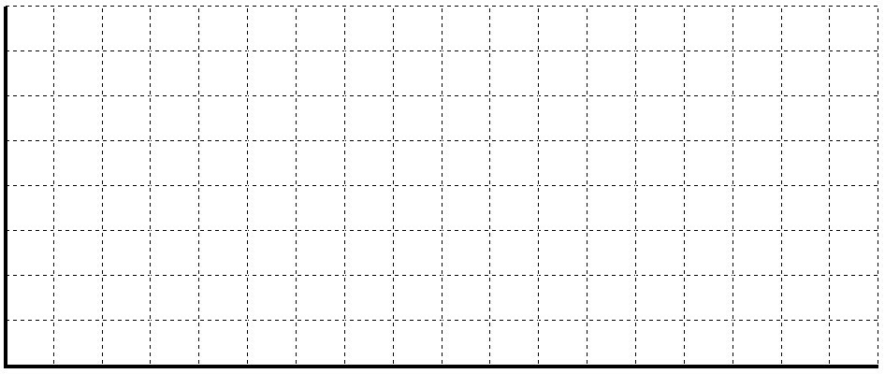
Answer:
Month | Expected Demand | Production Days | Demand per Day
July | 18,000 | 20 | 900.00
August | 21,000 | 23 | 913.04
September | 17,500 | 21 | 833.33
October | 12,500 | 21 | 595.24
November | 12,000 | 20 | 600.00
December | 13,500 | 21 | 642.86
TOTAL | 94,500 | 126 | Average =750

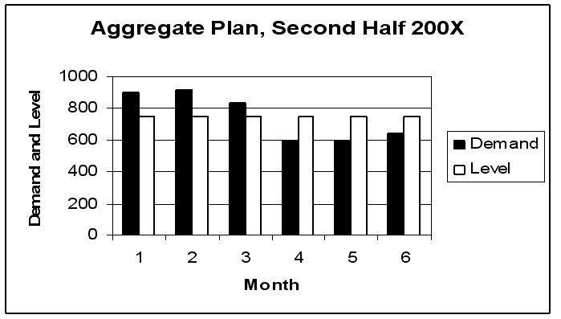
Diff: 2
Topic: Methods for aggregate planning
AACSB: Analytic Skills
Objective: LO13-3

117) Eagle Fabrication has the following aggregate demand requirements and other data for the upcoming four quarters.

Quarter | Demand |  | Previous quarter's output | 1500 units
1 | 1300 |  | Beginning inventory | 200 units
2 | 1400 |  | Stockout cost | $50 per unit
3 | 1500 |  | Inventory holding cost | $10 per unit at end of quarter
4 | 1300 |  | Hiring workers | $4 per unit
 |  |  | Laying off workers | $8 per unit
 |  |  | Unit cost | $30 per unit
 |  |  | Overtime | $10 extra per unit

Which of the following production plans is better: Plan A–chase demand by hiring and layoffs; or Plan B–produce at a constant rate of 1200 and obtain the remainder from overtime?
Answer: Plan A would cost $165,400, while Plan B would cost $167,400. In this case it is cheaper to vary work force than to use overtime.

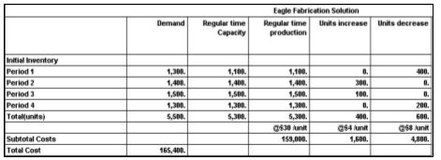
Plan B

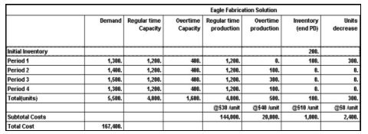
Diff: 2
Topic: Methods for aggregate planning
AACSB: Analytic Skills
Objective: LO13-4

118) Osprey Fabrication has the following aggregate demand requirements and other data for the upcoming four quarters.

Quarter | Demand |  | Previous quarter's output | 1300 units
1 | 1400 |  | Beginning inventory | 0 units
2 | 1200 |  | Stockout cost | $50 per unit
3 | 1600 |  | Inventory holding cost | $10 per unit at end of quarter
4 | 1500 |  | Hiring workers | $40 per unit
 |  |  | Laying off workers | $80 per unit
 |  |  | Subcontracting cost | $60 per unit
 |  |  | Unit cost | $30 per unit
 |  |  | Overtime | $15 extra per unit

Which of the following production plans is better: Plan A–chase demand by hiring and layoffs; Plan B–pure level strategy, or Plan C–1350 level with the remainder by subcontracting?
Answer: Plan A will cost $215,000, Plan B will cost $179,500, and Plan C will cost $183,500. Plan B is the cheapest, by a small margin.
Plan A
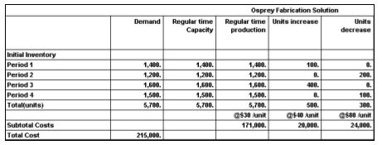

Plan B
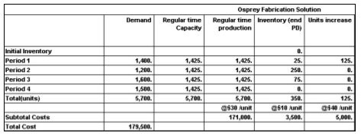

Plan C
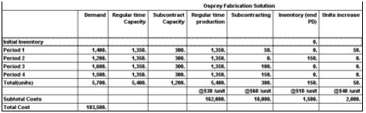
Diff: 2
Topic: Methods for aggregate planning
AACSB: Analytic Skills
Objective: LO13-4

119) A manufacturer of industrial seafood processing equipment wants you to develop an aggregate plan for the four quarters of the upcoming year using the following data on demand and capacity.

Quarter | Units | Regular Time | Over-  time | Sub-  contract |  | Initial inventory Regular time cost | 250 units $1.25/unit
1 | 200 | 400 | 80 | 100 |  | Overtime cost | $1.50/unit
2 | 750 | 400 | 80 | 100 |  | Subcontracting cost | 2.00/unit
3 | 1200 | 800 | 160 | 100 |  | Carrying cost | $0.50/unit/quarter
4 | 450 | 400 | 80 | 100 |  | No back ordering is allowed

a. Find the optimal plan using the transportation method.
b. What is the cost of the plan?
c. Does any regular time capacity go unused? How much in what periods?
d. What capacity went unused in this solution (list in detail)?
Answer: The optimal plan appears in the table below. A cost of 100 is assigned to "impossible" cells (no back orders are allowed.) Cost increases 0.50 for each period past the current period (carrying cost). The minimum cost solution is $3,360. Forty units of regular time capacity went unused in period 1. Other unused capacity includes OT-1, 80; Sub-1, 100; Sub-2, 100; and OT-4, 30; and Sub-4, 100.

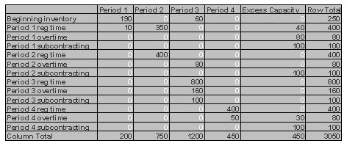
Diff: 2
Topic: Methods for aggregate planning
AACSB: Analytic Skills
Objective: LO13-4

120) Washington Laundry Products, Inc., makes commercial and industrial laundry machines (the kinds hotels use), and has these aggregate demand requirements for the next six months. The firm has regular capacity for 200 units, and overtime capacity for 40 more. Currently, subcontracting can supply up to 100 units per month, but the subcontracting firm may soon be unavailable.

Month | Demand |  | Costs and other data
1 | 220 |  | Previous output level | 150 units
2 | 160 |  | Beginning inventory | 100 units
3 | 200 |  | Stockout cost | $250 per unit
4 | 210 |  | Inventory holding cost | $100 per unit at end of month
5 | 200 |  | Unit Cost, regular time | $1,200 per unit
6 | 190 |  | Subcontracting | $2,000 per unit
 |  |  | Unit Cost, overtime | $1,500 per unit
 |  |  | Hiring workers | $200 per unit
 |  |  | Laying off workers | $500 per unit

Which is cheaper: to produce level, incurring back orders and inventory charges; or to produce a base quantity of 120, using first, overtime, then subcontracting, to meet demand?
Answer: The cost of the level strategy is $1,326,000. The cost of the mixed strategy is $1,499,000. The added holding costs of the level strategy are far cheaper than the added overtime and subcontracting costs of the mixed strategy, as well as hedging against the potential loss of subcontracting.

Level Strategy
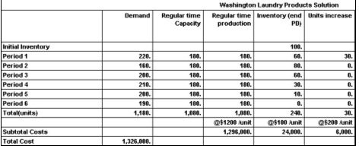

Mixed Strategy

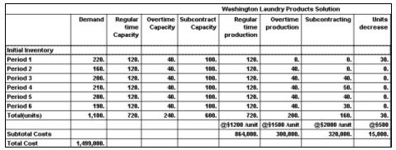
Diff: 2
Topic: Methods for aggregate planning
AACSB: Analytic Skills
Objective: LO13-4

121) Reddick's Specialty Electronics makes weatherproof surveillance systems for parking lots. Demand estimates for the next four quarters are 25, 9, 13, and 17 units. Prepare an aggregate plan that uses inventory, regular time and overtime and back orders. Subcontracting is not allowed. Regular time capacity is 15 units for quarters 1 and 2, 18 units for quarters 3 and 4. Overtime capacity is 3 units per quarter. Regular time cost is $2000 per unit, while overtime cost is $3000 per unit. Back order cost is $300 per unit per quarter; inventory holding cost is $100 per unit per quarter. Beginning inventory is zero.

The data inputs for this problem, and the optimal solution, generated by microcomputer software, appear below. Answer the following questions based on the scenario and the solution.
a. How many total units will be produced in quarter 1 for delivery in quarter 1?
b. How many units in total will be used to fill back orders over the four quarters?
c. What is the cost to produce one unit in Quarter 4 using overtime to deliver in quarter 1 (filling a back order)?
d. At the end of quarter 3, what is the ending inventory of finished systems?
e. What is the total cost of the solution?
f. What is the average cost per unit?
Answer:
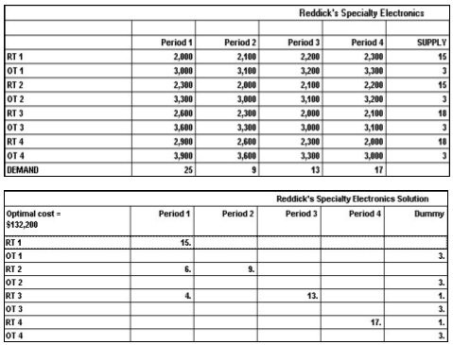

a. 15; b. 10; c. $3,900; d. 0; e. $132,200; f. 132200 / 64 = $2,066.
Diff: 2
Topic: Methods for aggregate planning
AACSB: Analytic Skills
Objective: LO13-4
122) Osprey Machine Works has the following demand requirements and other data for the upcoming four quarters.

Quarter | Demand |  | Previous quarter's output | 2500 units
1 | 2300 |  | Beginning inventory | 200 units
2 | 2400 |  | Stockout (backorder) cost | $50 per unit
3 | 2600 |  | Inventory holding cost | $10 per unit at end of quarter
4 | 2100 |  | Hiring workers | $4 per unit
 |  |  | Laying off workers | $8 per unit
 |  |  | Unit cost | $30 per unit
 |  |  | Overtime | $10 extra per unit

What is the total cost of pursuing a level aggregate plan over the coming year?
Answer: Requirements total 9400 units, of which 200 are already in stock. A level rate of 2300 units will meet demand while using up beginning inventory. Costs associated with this plan are:

Cost element | Detail | Extension
Layoffs | $8 x 200 units for the reduction from 2500 units to 2300 units | $1,600
Holding | There will be 200 units ending inventory at end of Q1 and 100 units at end of Q2, creating an inventory holding cost of $10 x 300 units | $3,000
Stockout | In Q3, 200 units go unfilled until Q4, for a stockout cost of $50 x 200 | $10,000
Unit cost | $30 x 9,200 | $276,000
TOTAL |  | $290,600.00

Diff: 2
Topic: Methods for aggregate planning
AACSB: Analytic Skills
Objective: LO13-4
123) Golden Eagle Machine Works has the following demand requirements and other data for the upcoming four quarters.

Quarter | Demand |  | Previous quarter's output | 2500 units
1 | 2300 |  | Beginning inventory | 200 units
2 | 2400 |  | Stockout (backorder) cost | $50 per unit
3 | 2600 |  | Inventory holding cost | $10 per unit at end of quarter
4 | 2100 |  | Hiring workers | $4 per unit
 |  |  | Laying off workers | $8 per unit
 |  |  | Unit cost | $30 per unit

What is the total cost of pursuing a chase aggregate plan over the coming year?
Answer: For a chase strategy, quarterly production should be Q1: 2100; Q2: 2400; Q3: 2600; and Q4: 2100. Costs associated with this plan are:

Cost element | Detail | Extension
Layoffs | Reductions are 400 units in Q1 and 500 units in Q4. Costs are 900 x $8 | $7,200
Hiring | Increases are 300 units in Q2 and 200 units in Q3. Costs are 500 x $4 | $2,000
Unit cost | $30 x 9,200 | $276,000
TOTAL |  | $285,200.00

Diff: 2
Topic: Methods for aggregate planning
AACSB: Analytic Skills
Objective: LO13-4
124) An electronics manufacturer makes video security systems for parking lots. Demand estimates for the next four quarters are 15, 9, 23, and 17 units. Prepare an aggregate plan that uses inventory, regular time, overtime, and back orders. Subcontracting is not allowed. Regular time capacity is 12 units for quarters 1 and 2, 15 units for quarters 3 and 4. Overtime capacity is 6 units per quarter. Regular time cost is $20,000 per system, while overtime cost is $30,000 per unit. Back order cost is $2000 per system per quarter; inventory holding cost is $500 per unit per quarter. Beginning inventory is zero.

Complete the table of data inputs for solving this aggregate planning problem with the transportation method. Specifically, how many sources are there, and how many destinations? What is the supply from each source, and the demand of each destination? What is the cost of each source-destination pair?
Answer: There are eight sources: regular time and overtime for each quarter. There are four destinations, one for each quarter. The four demands are the quarterly demand estimates. The eight supplies are the regular time and overtime capacities of each quarter. The cell costs for regular time begin at $20,000, and increase rightward by the carrying cost increment, and increase downward by the backorder increment. The data table appears below.

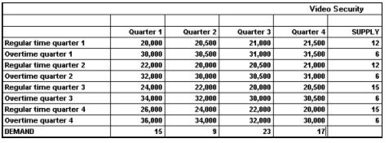
Diff: 2
Topic: Methods for aggregate planning
AACSB: Analytic Skills
Objective: LO13-4

125) Houma Containers, Inc., makes industrial fiberglass tanks that are used on offshore oil platforms. Demand for the next four months and capacities of the plant are shown in the table below. Unit cost on regular time is $400. Overtime cost is 150% of regular time cost. Subcontracting is available in substantial quantity but at a very high cost, $1100 per unit. Holding costs are $200 per tank per month; back orders cost the firm $1000 per unit per month. Houma's management believes that the transportation algorithm can be used to optimize this scheduling problem. The firm has no beginning inventory and anticipates no ending inventory.

 | March | April | May | June
Demand | 300 | 500 | 300 | 350
Regular capacity | 200 | 200 | 250 | 250
Overtime capacity | 50 | 50 | 50 | 50
Subcontract cap. | 150 | 100 | 100 | 150

a. How many units will be produced on regular time in June?
b. How many units will be produced by subcontracting over the four-month period?
c. What will be the inventory at the end of April?
d. What will be total production from all sources in April?
e. What will be the total cost of the optimum solution?
f. Does the firm utilize the expensive options of subcontracting and back ordering? When; why?
Answer: (a) 250; (b) 350; (c) 0, and 50 units are back ordered; (d) 350; (e) $935,000; (f) they use subcontracting every month; there are back orders in April filled with May production. The firm has so little excess capacity, even with the short-term options, that it must utilize almost every unit available, which forces the use of the more expensive options. The data table and solution table appear below.

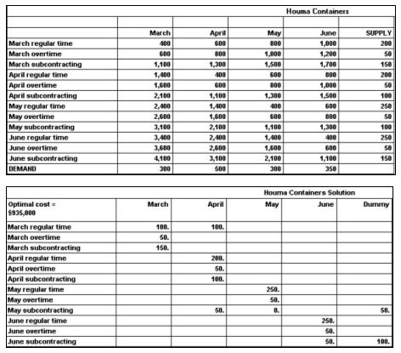
Diff: 2
Topic: Methods for aggregate planning
AACSB: Analytic Skills
Objective: LO13-4

126) Fred's Fabrication has the following aggregate demand requirements and other data for the upcoming four quarters.

Quarter | Demand |  | Previous quarter's output | 800 units
1 | 700 |  | Beginning inventory | 0 units
2 | 900 |  | Stockout cost | $100 per unit
3 | 1200 |  | Inventory holding cost | $10 per unit at end of quarter
4 | 600 |  | Hiring workers | $20 per unit
 |  |  | Laying off workers | $40 per unit
 |  |  | Subcontracting cost | $200 per unit
 |  |  | Unit cost | $100 per unit

Which of the following production plans is better: Plan A–chase demand by hiring and layoffs; Plan B–pure level strategy, or Plan C–700 level with the remainder by subcontracting?
Answer: Plan A has cost of $378,000, plan B has cost of $368,500, and plan C has cost of $425,000. Plan B has the lowest cost. Note that Plan C has an ending inventory of 100 units, which is the result of level production which exceeds demand in the last quarter.
Plan A -- Chase strategy
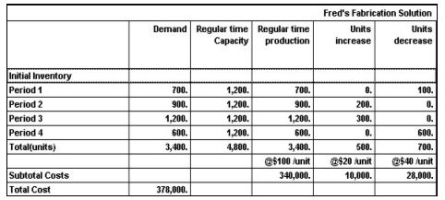
Plan B -- Level production, 850 per quarter
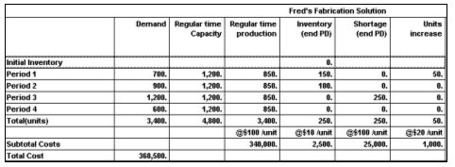

Plan C -- 700 units level, with subcontracting
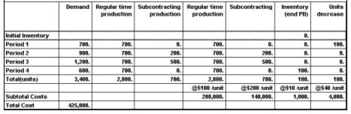
Diff: 2
Topic: Methods for aggregate planning
AACSB: Analytic Skills
Objective: LO13-4
127) Byron's Manufacturing makes tables. Demand for the next four months and capacities of the plant are shown in the table below. Unit cost on regular time is $40. Overtime cost is 150% of regular time cost. Subcontracting is available in substantial quantity at $75 per unit. Holding costs are $5 per table per month; back orders cost the firm $10 per unit per month. Byron's management believes that the transportation algorithm can be used to optimize this scheduling problem. The firm has 50 units of beginning inventory and anticipates no ending inventory.

 | March | April | May | June
Demand | 400 | 600 | 600 | 700
Regular capacity | 400 | 400 | 400 | 400
Overtime capacity | 100 | 100 | 100 | 100
Subcontract cap. | 150 | 50 | 50 | 50

a. How many units will be produced on regular time in June?
b. How many units will be produced by subcontracting over the four-month period?
c. What will be the inventory at the end of April?
d. What will be total production from all sources in April?
e. What will be the total cost of the optimum solution?
f. Does the firm utilize the expensive options of subcontracting and back ordering? When; why?
Answer: (a) 400; (b) 250; (c) 0; (d) 550; (e) Total Cost = $109,750; (f) The firm uses subcontracting, but not backordering; there is no production in one month for "delivery" in an earlier month. Subcontracted quantities are 100 in March, 50 each in April, May, and June. The data and solution tables appear below.

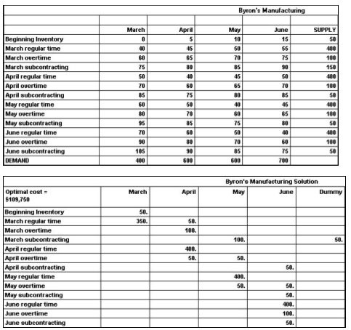
Diff: 2
Topic: Methods for aggregate planning
AACSB: Analytic Skills
Objective: LO13-4
128) A small private university normally charges the same price –$200–per credit-hour for all courses and for all students. While the university is pretty near capacity in the fall and spring, it finds that its classrooms are only about 60 percent occupied during the summer session. A student of operations management (who has recently read this chapter) wonders if yield management might be useful to both the university and its students alike. This student, with help from some economics majors, estimates a demand curve for summer course enrollment. Points on this demand curve include 9000 credit-hours at the current rate of $200, 12,000 credit hours at $180, 15,000 credit-hours at $160, and 18,000 credit-hours at $140. Based on this demand curve, what price point would best serve the university, if its objective is the greatest revenue for the summer session?
Answer: The student must consider that since 9000 hours is 60 percent of capacity there is a classroom capacity of 15,000 credit-hours during the summer session. The lowest price generates the most revenue, but it is based on 18,000 credit-hours, which is beyond capacity. At $200 per credit hour, revenues would be $1,800,000; at $180, revenues would be $2,160,000; at $160, revenues would be $2,400,000; and at $140, demand exceeds capacity. The $160 price point yields the most revenue of the feasible price points.
Diff: 2
Topic: Yield management
AACSB: Analytic Skills
Objective: LO13-5

129) A professional services firm is investigating yield management as a means of taking advantage of unused capacity. Analysts for this firm estimate a demand curve for the firm's service, which is sold by the hour. Points on this demand curve include 9000 hours at the current rate of $60 per hour, 9500 hours at $55, 10,000 hours at $50, and 10,500 hours at $45. Based on this demand curve, what price point would be best for the firm, if its objective is maximum revenue?
Answer: The yields of these price points are as follows: at $60 per hour, revenue is $540,000; at $55, revenue is $522,500; at $50, revenue is $500,000; and at $45, revenue is $472,500. The firm would be well advised not to lower its price, since that will not raise revenue. The lower prices will generate more demand, and utilize some unused capacity, but the firm's revenues will fall. (Demand in this case is pretty inelastic).
Diff: 2
Topic: Yield management
AACSB: Analytic Skills
Objective: LO13-5

130) A large consulting firm is deciding on if its workforce should be expanded, maintained, or decreased. Suppose that demand is given in week long projects, and that a consultant can work on 3 projects each month (1 week off for personal leave and/or other duties such as conferences, etc). Currently there are 25 consultants. Ten consultants are trained for LEAN and 15 for Six Sigma, with 5 of those consultants being overlaps (the consultant is trained for BOTH LEAN and Six Sigma). Assume that all consultants can do the general work. Complete the table (the forecast period is an upcoming month) and prepare a recommendation.

Category | Best Forecast (# projects) | Likely Forecast (# projects) | Worst Forecast (# projects) | Max Demand in # of people | Number of Qualified People
LEAN | 42 | 24 | 12
Six Sigma | 45 | 36 | 30
General | 75 | 60 | 57

Answer:
Category | Best Forecast (# projects) | Likely Forecast (# projects) | Worst Forecast (# projects) | Max Demand in # of people | Number of Qualified People
LEAN | 42 | 24 | 12 | 14 | 10
Six Sigma | 45 | 36 | 30 | 15 | 15
General | 75 | 60 | 57 | 25 | 25

NOTE: Student responses will vary but should follow the same principles.
Under the likely condition (24+36+60)/3 = 40 total consultants are needed but only 25 are available. Under the worst forecast 33 consultants are needed total but again only 25 are available. Thus the firm should hire more consultants, but which type?
4 additional LEAN trained consultants are needed to meet maximum demand, while the number of Six Sigma consultants is adequate. However, there is an overlap of 5 consultants being counted in each category, so the hiring recommendation must be at least 4 LEAN consultants and then 5 additional consultants that can perform either LEAN or Six Sigma, for a total of 9 trained consultants. To meet likely demand 15 total consultants must be added, so 6 general consultants at a minimum should be hired. Thus the recommendation is for: At least 15 consultants, with a minimum of 4 trained in LEAN and a minimum total of 9 trained in either LEAN or Six Sigma.
Diff: 3
Topic: Aggregate planning in services
AACSB: Analytic Skills
Objective: no LO
131) A train company is considering applying yield management principles to its ticket sales. Suppose that there is no variable cost in the operation, only a fixed cost to run each train. The company decides that a student ticket will sell for half the cost of a business ticket. If demand for the business tickets is given by 50-3x where x is the sales price of a business ticket and demand for student tickets is given by 70-y^2 where y is the price of a student ticket how much should the company charge for tickets to maximize revenue?
Answer: The crucial step is to relate x and y, using the relation that 2*y=x.
Revenue from the business tickets is Demand*cost = x(50-3x)
Revenue from the student tickets is demand*cost = y(70-y^2)
Total revenue is thus x(50-3x)+y(70-y^2)
Substituting yields 2y(50-6y)+y(70-y^2) as total revenue
Students must then either graph this function to find its maximum feasible solution, or know that when the derivative is 0 the function is at its local maximum (for the feasible solution range of x and y > 0)
The derivative is given by dR/dy=-3y^2-24y+170, using either a calculator solver or the quadratic equation yields y=-12.5 or y=4.52. Since price cannot be negative y must be set at $4.52 and subsequently x is $9.04. Thus the company should charge students $4.52 and business travelers $9.04

*Note- this problem requires use of basic calculus and have content related to, but not expressly performed in, the text. As such they are more difficult than usual problems and require reflective thinking on the students' behalf.
Diff: 3
Topic: Yield management
AACSB: Analytic Skills
Objective: LO13-5

132) A manager is applying the transportation model of linear programming to solve an aggregate planning problem. Demand in period 1 is 100 units and in period 2 demand is 150 units. The manager has 125 hours of regular employment available for $10/hour each period. In addition, 50 hours of overtime are available for $15/hour each period. If holding costs are $2 per unit each period, how many hours of regular employment should be used in period 1 (assume demand must be met in both periods 1 and 2 for the lowest possible cost and that production is 1 unit per hour)?
Answer: In period 2 all regular work will be used for a total of 125 units. However, 150 are needed and 25 units must be made with either overtime from period 2 or carried from period 1. In period 1 100 units are made with regular work, leaving 25 hours available. The cost to make 25 units and carry them into period 2 is $12/unit (hourly rate + holding cost). The cost to make these units with overtime in period 2 would be $15/unit, so the units should be produced in period 1. Thus the total hours of regular employment should be 125 for both periods 1 and 2.

*Note- this problem requires use of basic calculus and have content related to, but not expressly performed in, the text. As such they are more difficult than usual problems and require reflective thinking on the students' behalf.
Diff: 3
Topic: Methods for aggregate planning
AACSB: Analytic Skills
Objective: LO13-4
133) A manufacturing plant has created the following forecast and would like to apply a graphical aggregate planning method. Complete the table and calculate the difference between Jan.'s forecast demand per working day vs a level production model for the entire period?

Month | Expected Demand | Production Days | Demand per Day (to the nearest whole unit)
Jan. | 1800 | 22
Feb. | 1400 | 18
Mar. | 1600 | 21

Answer:
Month | Expected Demand | Production Days | Demand per Day (to the nearest whole unit)
Jan. | 1800 | 22 | 82
Feb. | 1400 | 18 | 78
Mar. | 1600 | 21 | 76

Total expected demand/ Total # working days = level production rate = 79 units/day
Thus the difference between Jan. and the level production is 3 units.

*Note- this problem requires use of basic calculus and have content related to, but not expressly performed in, the text. As such they are more difficult than usual problems and require reflective thinking on the students' behalf.
Diff: 3
Topic: Methods for aggregate planning
AACSB: Analytic Skills
Objective: LO13-4
134) A hotel chain is considering using yield management to increase profits. Its plan is to sell unsold rooms at a discounted rate very close to the night of stay. For example, an unsold Friday night room would be discounted early in the week. It estimates that the percentage of sold rooms (total) would be equal to 50+X, where X is the % discounted off of regular price. Meanwhile the % of rooms sold for full price compared to the discount would be 100-2X (some people would wait to book gambling a discount would happen). Find the ideal discount %.
Answer: Revenue is equal to demand * (% sold at full price * full price +% sold at discounted price * discounted price)
Since no price is given, full price can be assumed to be 100 hundred dollars for calculations, making the discounted price simply 100-X.
Thus revenue is (50+X)[ (100-2x)(100)+(2x)(100-x) ] which simplifies to
-2x^3-100x^2+10000x+500000
Students may then either graph and trace to find the maximum or solve for when the derivative is equal to 0 in the feasible range (will give the local maximum).
The derivative is given by -6x^2-200x+10000, setting this equal to zero gives x=27.43
Thus the hotel should discount rooms by 27.43% to maximize revenue.

*Note- this problem requires use of basic calculus and have content related to, but not expressly performed in, the text. As such they are more difficult than usual problems and require reflective thinking on the students' behalf.
Diff: 3
Topic: Yield management
AACSB: Analytic Skills
Objective: LO13-5

